Quantum Machine Learning for Land Cover Classification: Evaluating Variational Quantum Classifiers Using Sentinel-2 Imagery

Carlos Henrique de Moura Silva1

1Serpro – Serviço Federal de Processamento de Dados

CEP 04766-900 – São Paulo – SP – Brazil

carlos-henrique.silva@serpro.gov.br

**Abstract.** The identification of soybean and forest areas using remote sensing data is of great relevance for environmental monitoring and agricultural management. This study evaluates the feasibility of classifying these land cover types using machine learning techniques in a quantum computing environment. The proposed methodology is tested in a quantum computing simulator to assess its classification performance and potential advantages over classical approaches. Preliminary results suggest that quantum machine learning could offer promising improvements in land cover classification, particularly in complex and high-dimensional datasets. This study contributes to the growing field of quantum remote sensing, providing insights into the applicability of quantum computing for large-scale land use classification task.

1. Introduction

Land cover classification using remote sensing data is fundamental for environmental monitoring, agricultural management, and tracking land-use changes (Foody, 2002). Classical machine learning models, such as Support Vector Machines (SVM) and Random Forests, have demonstrated robust accuracy for classifying vegetation types based on satellite-derived spectral data (Belgiu & Drăguţ, 2016). Nevertheless, the growing size and complexity of remote sensing datasets pose challenges related to computational efficiency and scalability (Zhang et al., 2016).

Quantum computing has emerged as a promising approach to overcome these limitations, offering significant computational advantages in specific tasks, such as optimization and classification (Biamonte et al., 2017). Variational Quantum Algorithms (VQAs), particularly the Variational Quantum Classifier (VQC), integrate quantum feature mapping with parameterized quantum circuits and have potential to enhance classification accuracy and efficiency in processing complex, high-dimensional remote sensing data (Havlíček et al., 2019).

This study evaluates the potential of quantum machine learning, specifically VQC, for classifying soybean and forest areas using Sentinel-2 imagery. We utilize spectral bands B2 (blue), B3 (green), and B4 (red)—all with 10-meter spatial resolution—alongside annual mean Normalized Difference Vegetation Index (NDVI), known for its effectiveness in assessing plant health and canopy structure.

Our research involves training and evaluating a Variational Quantum Classifier implemented using Qiskit's quantum simulator, comparing its classification accuracy with that of a conventional neural network model. The goal is to determine the practicality and effectiveness of quantum methods for remote sensing classification tasks.

1. Material and Methods

The study utilized Sentinel-2 satellite imagery from the COPERNICUS/S2_SR collection, focusing on regions in Rio Grande do Sul, Brazil. Representative sampling points for soybean fields and forest formations were manually selected.

Imagery from January 1, 2020, to December 31, 2020, was obtained via Google Earth Engine (GEE), with cloud-contaminated pixels removed using the QA60 quality band mask. A median composite image was generated using spectral bands B2 (blue), B3 (green), B4 (red) and NDVI, reducing temporal noise. Histogram and kernel density estimation (KDE) plots highlighted distinct spectral differences between soybean and forest classes; forests demonstrated low reflectance in visible bands and high NDVI values, whereas soybean fields displayed the opposite characteristics (Figure 1).

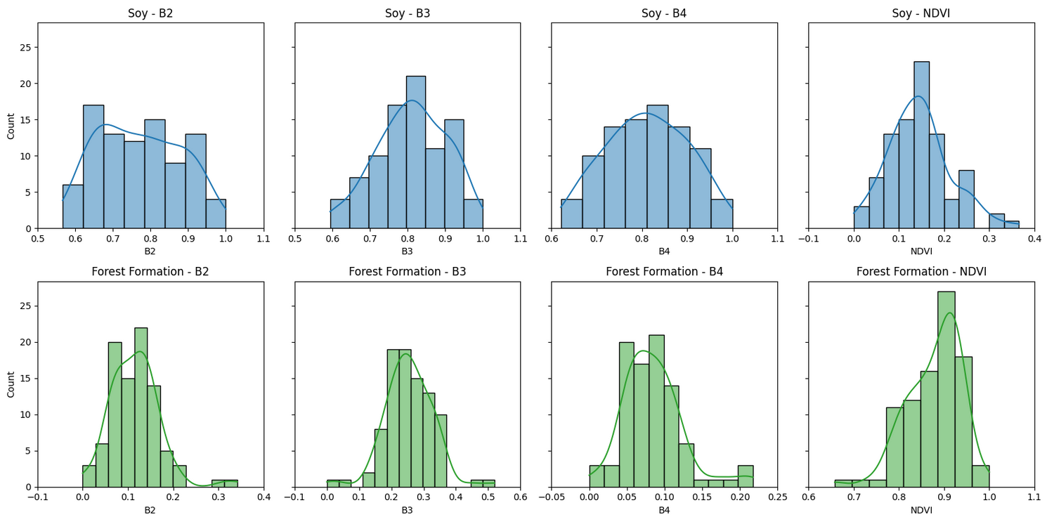 Figure 1. Histogram and kernel density estimation (KDE)

Sampling points for both classes were converted into a FeatureCollection in GEE, labeled categorically (1 for soybean, 2 for forest), and spectral data were extracted at a 10-meter spatial resolution. The dataset, exported as CSV, underwent Min-Max normalization in Python to standardize feature scales and was divided into stratified training (80%) and testing (20%) sets.

A classical neural network model was implemented using Python and TensorFlow/Keras. This model was trained using normalized spectral features (B2, B3, B4, NDVI) and labels adjusted to a binary scale (0 for soybean, 1 for forest). The neural network comprised two hidden layers (64 and 32 neurons respectively, using ReLU activation) and an output layer with two neurons (softmax activation). Training was conducted over 50 epochs with batch sizes of 32, employing the Adam optimizer and sparse categorical cross-entropy loss. Predictions from the trained neural network were exported, reclassified into original categorical values (1 and 2), and saved in a CSV file for subsequent spatial analysis Chollet (2021).

Additionally, a Variational Quantum Classifier (VQC) was implemented using Qiskit’s quantum simulator. Spectral features were encoded into quantum states through a ZZFeatureMap circuit, leveraging quantum principles such as superposition and interference to effectively represent complex, nonlinear relationships within the dataset. The quantum circuit consisted of four qubits (q₀, q₁, q₂, and q₃), each corresponding to one spectral feature (B2, B3, B4, and NDVI, respectively). Initially, each qubit was placed into an equal superposition state by applying Hadamard gates (H). Subsequently, phase rotation gates (P) were applied individually to each qubit, encoding feature values directly as rotation angles proportional to the normalized spectral data. Controlled ZZ interaction gates were then introduced between pairs of qubits, embedding feature correlations into the quantum state. These interactions involved parameterized rotation angles defined as a function of pairwise feature differences, enhancing the model's capacity to capture intricate relationships within the remote sensing data (Figure 2).

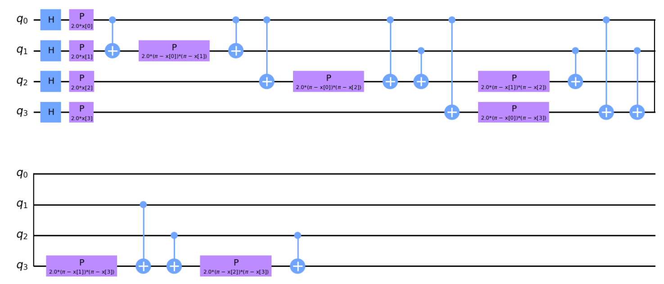 Figure 2. ZZFeatureMap

The RealAmplitudes ansatz utilized in this study comprised a parameterized quantum circuit structure designed to effectively explore the quantum state space. Specifically, the circuit consisted of four qubits (q₀, q₁, q₂, and q₃), each corresponding to a spectral feature. It included three repetitions (reps=3) of rotation gates around the Y-axis (RY), followed by controlled NOT (CNOT) entanglement gates arranged to ensure thorough entanglement among all qubits. Each repetition layer contained individual RY gates with independently optimized rotation angles θ[i], enabling the ansatz to learn intricate feature dependencies and nonlinear patterns. Circuit parameters were optimized using the COBYLA algorithm across 80 iterations, and the model's predictive accuracy was subsequently evaluated against the test dataset (Figure 3).

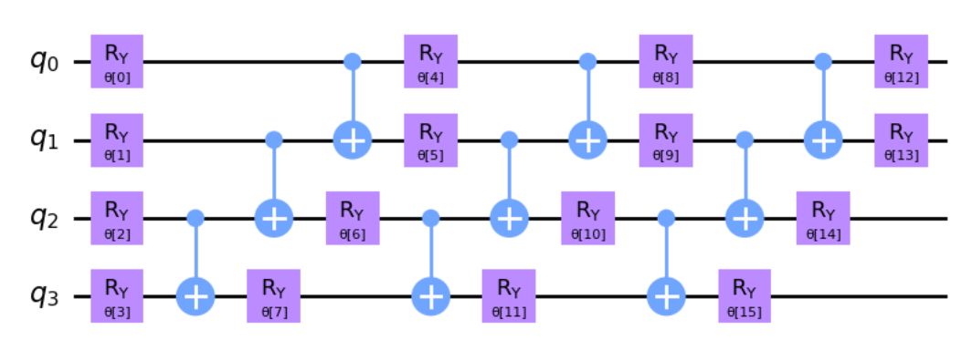 Figure 3. ansatz

Final model predictions (quantum and classical) were spatially analyzed and visualized by rasterizing the classification outputs using GEE.

1. **Results and Discussion**

To evaluate the performance of the classification models, an area of approximately 44.1 hectares located in the municipality of Júlio de Castilhos, Rio Grande do Sul, Brazil, was selected (Figure 4). This region encompasses two distinct land cover types: forest formation and soybean cultivation. The reference data for assessing model accuracy was derived from the MapBiomas Collection 9 classification (MapBiomas, 2022), which provides land cover information at a 30-meter spatial resolution, categorizing pixels as either soybean or forest formation (Figure 5).

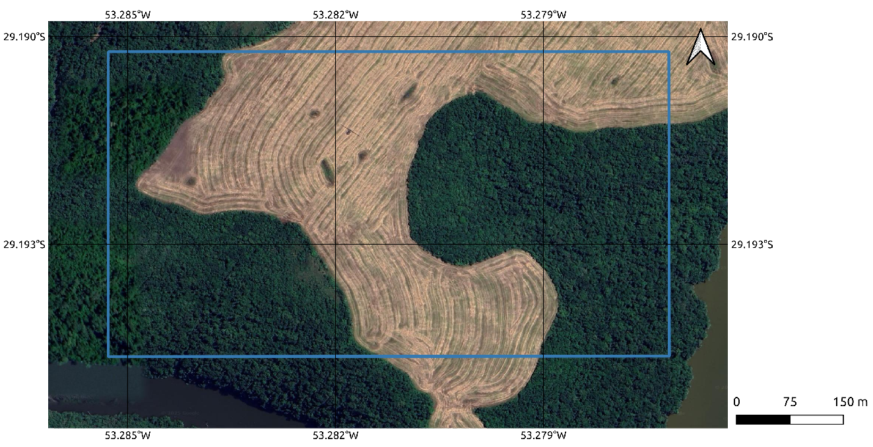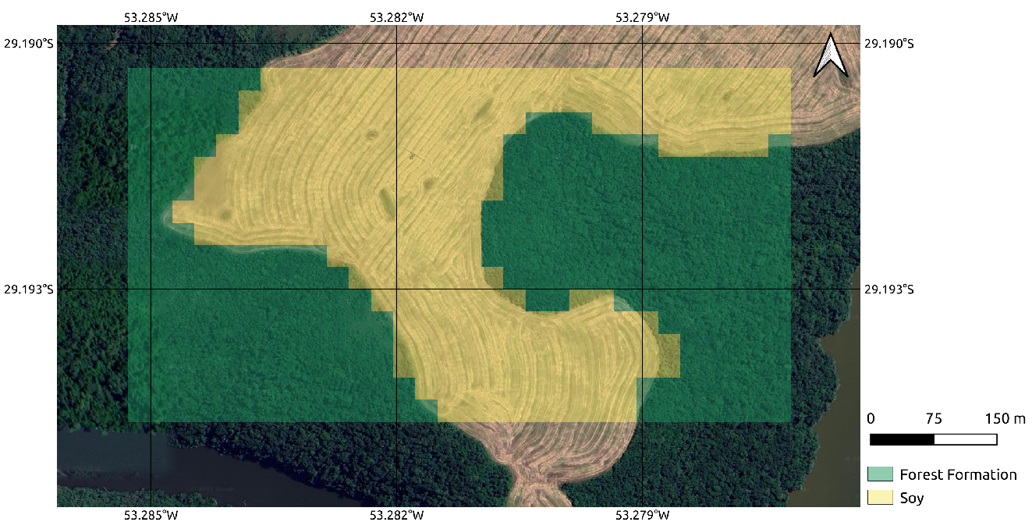 Figure 4. Area Selected Figure 5. MapBiomas

Two raster files with a higher spatial resolution of 10 meters were generated to represent predictions from two different classification approaches: a classical neural network (Figure 6) and a Variational Quantum Classifier (VQC) (Figure 7) implemented through the Qiskit Machine Learning package, run on a quantum simulator. The accuracy of these predictive models was quantitatively assessed by comparison against the MapBiomas raster, treated as the ground truth.

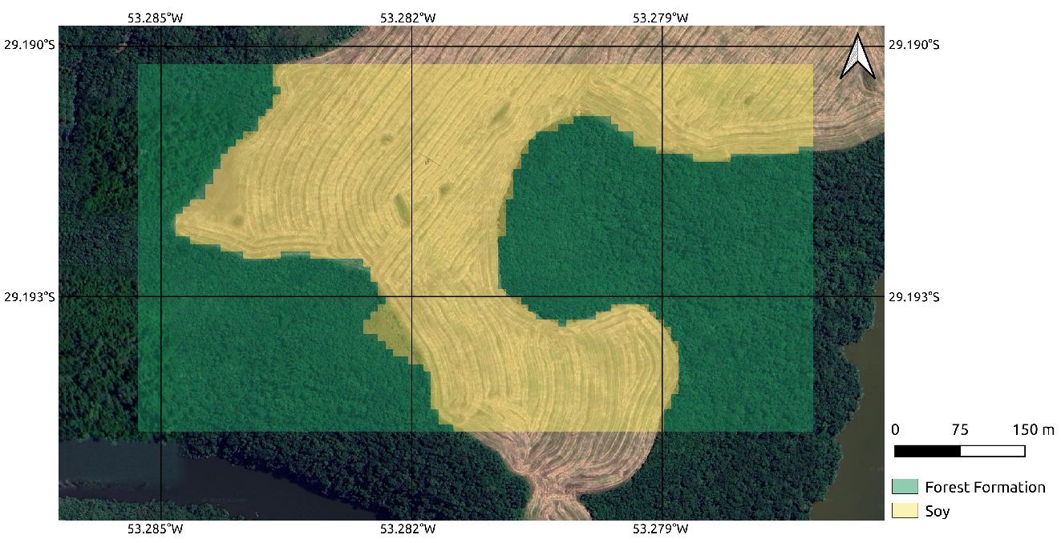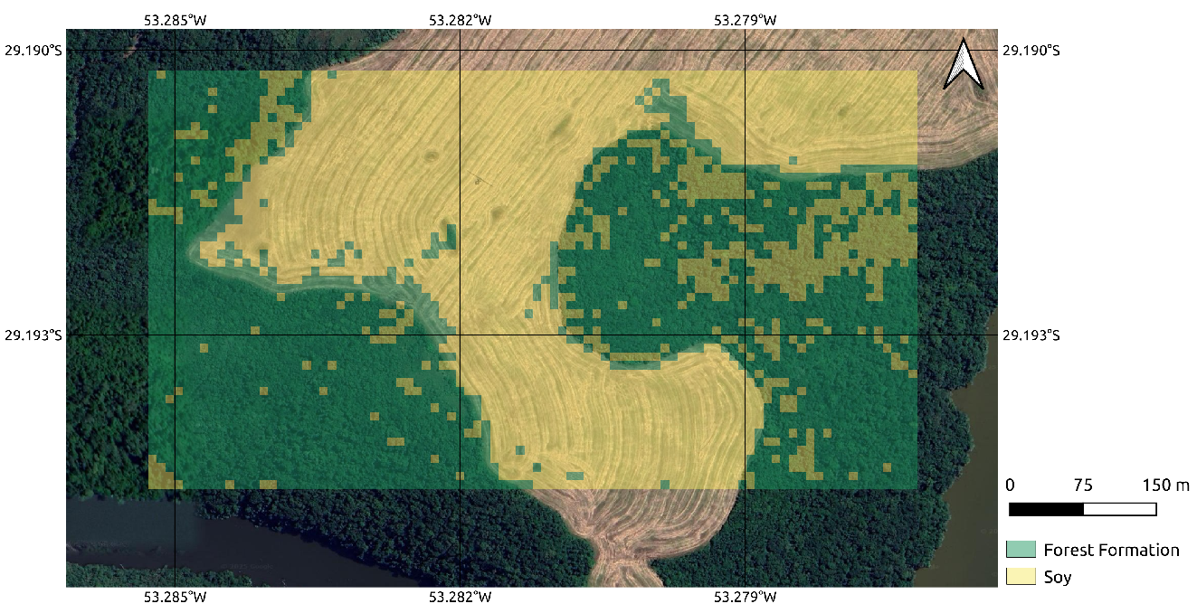 Figure 6. Classical Neural Network Figure 7. VQC

The classification results indicate significant differences between the classical and quantum models. The classical neural network achieved a high accuracy, correctly classifying 92.23% (1,910 pixels) of soybean areas and misclassifying only 7.77% (161 pixels) as false positives. Additionally, it demonstrated a robust performance in identifying forest formation, correctly classifying 94.70% (2,215 pixels) with only 5.30% (124 pixels) falsely identified as soybean.

Conversely, the quantum classifier (VQC) exhibited comparatively lower accuracy. For soybean predictions, the model accurately classified 76.58% (1,769 pixels) of the area, but it incorrectly classified a substantial 23.42% (541 pixels). The VQC performed better in classifying forest formation, with an accuracy of 87.57% (1,839 pixels), but still presented a considerable false positive rate of 12.43% (261 pixels) (Figure 8).

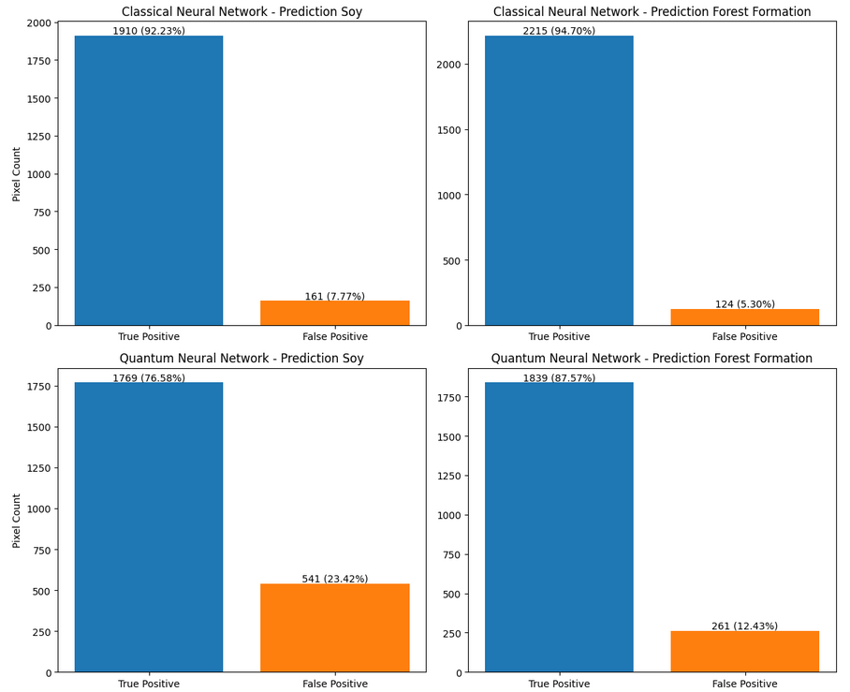 Figure 8. Classification Results

The discrepancies observed between the classical neural network and the VQC predictions underscore the challenges inherent in quantum classifiers, particularly in complex agricultural landscapes characterized by mixed land-use types. The superior performance of the classical neural network in this specific scenario might be attributed to its capability to manage spatial complexities and heterogeneity within high-resolution imagery more effectively. Nonetheless, the quantum approach provides valuable insights and indicates potential avenues for future research aimed at improving quantum machine learning techniques for environmental and agricultural applications.

These findings highlight the importance of model selection and resolution considerations in satellite imagery classification tasks, demonstrating that classical approaches remain highly effective, while quantum methods, though currently less accurate, offer promising directions for methodological advancements.

1. Conclusions

This study evaluated the potential of Variational Quantum Classifiers (VQC) compared to classical neural network models in classifying land cover types, specifically soybean fields and forest formations, using Sentinel-2 satellite imagery. While the classical neural network demonstrated superior accuracy, correctly classifying over 90% of both land cover types, the quantum classifier yielded lower accuracy, particularly in distinguishing soybean fields. The observed differences highlight current limitations of quantum classifiers in handling complex spatial and spectral variations inherent in agricultural landscapes.

Despite these limitations, the quantum approach presents promising opportunities for advancements in computational efficiency and scalability, especially as quantum computing technologies mature. Future research should focus on improving quantum classification methods by optimizing quantum circuit design, exploring alternative quantum feature encodings, and evaluating the impact of quantum noise mitigation strategies. Additionally, migrating from quantum simulations to experiments on real quantum hardware platforms represents an essential next step, allowing assessment of model robustness under realistic quantum noise and connectivity constraints. Such research will be crucial for determining the practical viability and future applications of quantum computing in environmental remote sensing and land-use classification tasks. The codes used in this article are at *https://github.com/kikosmoura/quantum_simulator*.

References

Belgiu, M., & Drăguţ, L. (2016). Random forest in remote sensing: A review of applications and future directions. ISPRS Journal of Photogrammetry and Remote Sensing, 114, 24-31.

Biamonte, J., et al. (2017). Quantum machine learning. Nature, 549(7671), 195-202.

Foody, G. M. (2002). Status of land cover classification accuracy assessment. Remote Sensing of Environment, 80(1), 185-201.

Havlíček, V., et al. (2019). Supervised learning with quantum-enhanced feature spaces. Nature, 567(7747), 209-212.

MapBiomas. (2022). Coleção 9 da Série Anual de Mapas de Cobertura e Uso do Solo do Brasil. MapBiomas. Retrieved from https://mapbiomas.org

Zhang, L., et al. (2016). Deep learning for remote sensing data: A technical tutorial on the state of the art. IEEE Geoscience and Remote Sensing Magazine, 4(2), 22-40.

Chollet, F. (2021). Deep Learning with Python (2nd ed.). Manning Publications.